**Pemantauan Suhu, Kelembapan, dan Intensitas Cahaya Menggunakan ESP32, DHT22, LDR, dan LCD 16x2 pada Platform Wokwi**

**dan Visual Studio Code**

*Difa Aqilah*

*Fakultas Vokasi, Universitas Brawijaya*

*Email :* [*difaaqilah04@student.ub.ac.id*](mailto:difaaqilah04@student.ub.ac.id)

**Abstrak**

Praktikum ini bertujuan untuk menampilkan data suhu, kelembapan, serta intensitas cahaya melalui layar Oled secara real-time. Sensor DHT22 digunakan untuk membaca suhu dan kelembapan, sedangkan sensor LDR dipakai untuk mengukur cahaya sekitar. Semua data diproses menggunakan mikrokontroler ESP32 dan ditampilkan ke Oled melalui komunikasi I2C. Simulasi dilakukan menggunakan platform Wokwi serta pemrograman melalui Visual Studio Code menggunakan PlatformIO. Diharapkan melalui praktik ini, peserta memahami cara kerja dasar sensor serta bagaimana menampilkannya pada layar secara efisien.

Kata Kunci — *IoT, ESP32, DHT22, LDR, Oled, PlatformIO, Wokwi*

**Abstact**

This practicum aims to display temperature, humidity, and light intensity data in real-time on a Oled screen. The DHT22 sensor is used to measure temperature and humidity, while an LDR sensor is employed to detect ambient light levels. All sensor data is processed using the ESP32 microcontroller and displayed on the Oled via I2C communication. The simulation is carried out using the Wokwi platform, and the programming is done through Visual Studio Code using PlatformIO. Through this practicum, participants are expected to gain a deeper understanding of basic sensor functionality and how to effectively visualize environmental data on an Oled display.

Keywords — *IoT, ESP32, DHT22, LDR, Oled, PlatformIO, Wokwi*

**Pendahuluan**

Internet of Things (IoT) adalah konsep di mana perangkat dapat saling terhubung dan berbagi data melalui internet. Dalam dunia modern, IoT memudahkan berbagai aktivitas sehari-hari seperti monitoring suhu ruangan, kelembapan udara, atau intensitas pencahayaan. Praktikum ini menjadi sarana pembelajaran untuk mengenal bagaimana sensor bekerja dan bagaimana data dari sensor bisa ditampilkan secara langsung di layar Oled melalui mikrokontroler ESP32.

* 1. **Latar Belakang**

Di banyak bidang seperti pertanian, rumah pintar, dan manajemen energi, data lingkungan seperti suhu dan cahaya sangat penting. Untuk itu, dibutuhkan alat yang mampu membaca dan menampilkan informasi tersebut secara akurat dan real-time. Praktikum ini memanfaatkan ESP32 untuk mengelola data dari sensor dan menampilkannya ke layar Oled. Oled dipilih karena sederhana namun cukup untuk menampilkan informasi penting. Dengan demikian, sistem ini bisa diadaptasi untuk berbagai kebutuhan pemantauan lingkungan.

* 1. **Tujuan Praktikum**

Ada beberapa tujuan diadakannya praktikum ini sebagai berikut :

1. Memahami prinsip dasar kerja sensor DHT22 dan LDR.
2. Mempelajari koneksi antara sensor dan mikrokontroler ESP32.
3. Mengimplementasikan komunikasi I2C antara Oled dan ESP32.
4. Menampilkan data suhu, kelembapan, dan cahaya secara real-time ke layar Oled.
5. **Metodologi**
   1. **Alat dan Bahan**

Untuk melakukan praktikum simulasi suhu, kelembapan, dan cahaya berikut alat dan bahan yang digunakan:

* + ESP32
  + Sensor DHT22
  + Sensor LDR
  + Oled
  + Kabel jumper
  + Visual Studio Code + PlatformIO
  + Wokwi (untuk simulasi)
  1. **Langkah Implementasi**

• Buka situs Wokwi dan pilih board ESP32.

• Tambahkan komponen sensor DHT22, LDR, LCD 16x2, dan resistor.

• Pastikan rangkaian terhubung dengan benar di diagram Wokwi.

• Di Visual Studio Code, buat proyek baru dengan Board: DOIT ESP32 DEVKIT V1 dan Framework: Arduino.

• Kompilasi proyek untuk memastikan tidak ada error.

• Buat file wokwi.toml dan arahkan ke lokasi firmware.bin dan firmware.elf.

• Salin dan ubah file diagram.json agar menampilkan rangkaian simulasi dengan benar.

• Tulis kode program di main.cpp untuk membaca sensor dan menampilkan hasilnya di LCD.

• Jalankan simulasi dan perhatikan hasil tampilan dari pembacaan sensor.

**Hasil dan Pembahasan**

* 1. **Hasil Eksperimen**

Hasil simulasi dari kode yang telah dibuat di VSCode dengan ekstensi PlatformIO didapatkan

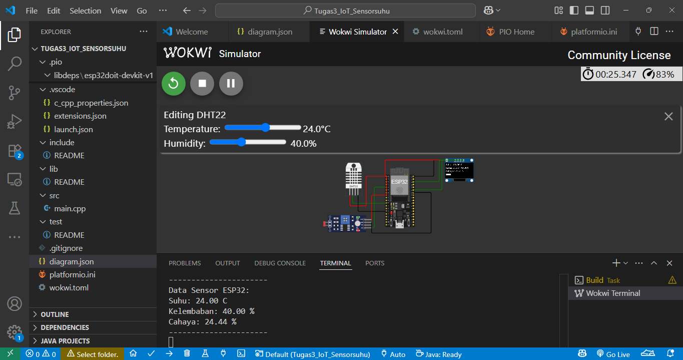

1. **Lampiran**

* Kode Program
* #include <Arduino.h>
* #include <Wire.h>
* #include <Adafruit_GFX.h>
* #include <Adafruit_SSD1306.h>
* #include <DHT.h>
* // Pin Sensor sesuai JSON
* #define DHTPIN 27       // Pin data DHT22
* #define LDR_AO 34       // Pin Analog LDR (AO)
* #define DHTTYPE DHT22   // Jenis sensor DHT22
* // Inisialisasi OLED
* #define SCREEN_WIDTH 128
* #define SCREEN_HEIGHT 64
* #define OLED_RESET    -1
* Adafruit_SSD1306 display(SCREEN_WIDTH, SCREEN_HEIGHT, &Wire, OLED_RESET);
* // Inisialisasi DHT22
* DHT dht(DHTPIN, DHTTYPE);
* void setup() {
* Serial.begin(115200);
* // Inisialisasi OLED
* if (!display.begin(SSD1306_SWITCHCAPVCC, 0x3C)) {
* Serial.println(F("SSD1306 allocation failed"));
* while (1);
* }
* display.clearDisplay();
* display.setTextSize(1);
* display.setTextColor(WHITE);
* // Inisialisasi DHT22
* dht.begin();
* }
* void loop() {
* // Baca sensor
* float suhu = dht.readTemperature();
* float kelembaban = dht.readHumidity();
* int cahayaAnalog = analogRead(LDR_AO);   // Baca nilai analog LDR (A0)
* // Konversi nilai analog LDR (0-4095) ke persen (0-100%)
* float cahayaPersen = (cahayaAnalog / 4095.0) * 100.0;
* // Cek apakah pembacaan sensor gagal
* if (isnan(suhu) || isnan(kelembaban)) {
* Serial.println("Gagal membaca dari sensor DHT!");
* return;
* }
* //  Format Serial Monitor sesuai JSON (berbaris)
* Serial.println("Data Sensor ESP32:");
* Serial.print("Suhu: "); Serial.print(suhu); Serial.println(" C");
* Serial.print("Kelembaban: "); Serial.print(kelembaban); Serial.println(" %");
* Serial.print("Cahaya: "); Serial.print(cahayaPersen); Serial.println(" %");
* Serial.println("----------------------"); // Pembatas
* //  OLED
* display.clearDisplay();
* display.setCursor(0, 0);
* display.print("Suhu: "); display.print(suhu); display.println(" C");
* display.setCursor(0, 16);
* display.print("Kelembaban: "); display.print(kelembaban); display.println("%");
* display.setCursor(0, 32);
* display.print("Cahaya: "); display.print(cahayaPersen); display.println("%");
* // Menampilkan grafik batang cahaya
* int barLength = map(cahayaAnalog, 0, 4095, 0, 100); // Ubah nilai LDR ke skala 0-100
* display.fillRect(0, 48, barLength, 8, WHITE); // Bar semakin panjang saat cahaya terang
* display.display();
* delay(2000);
* }
* Kode Diagram
* {
* "version": 1,
* "author": "Difa Aqilah",
* "editor": "wokwi",
* "parts": [
* { "type": "board-esp32-devkit-c-v4", "id": "esp", "top": 0, "left": 0, "attrs": {} },
* {
* "type": "board-ssd1306",
* "id": "oled1",
* "top": -35.26,
* "left": 211.43,
* "attrs": { "i2cAddress": "0x3c" }
* },
* { "type": "wokwi-dht22", "id": "dht1", "top": -18.9, "left": -139.8, "attrs": {} },
* {
* "type": "wokwi-photoresistor-sensor",
* "id": "ldr1",
* "top": 166.4,
* "left": -220,
* "attrs": {}
* }
* ],
* "connections": [
* [ "esp:TX", "$serialMonitor:RX", "", [] ],
* [ "esp:RX", "$serialMonitor:TX", "", [] ],
* [ "ldr1:AO", "esp:34", "green", [ "h9.6", "v-144.7" ] ],
* [ "dht1:SDA", "esp:27", "green", [ "v0" ] ],
* [ "dht1:VCC", "esp:3V3", "red", [ "v38.4", "h57.6", "v-105.6" ] ],
* [ "oled1:GND", "esp:GND.2", "black", [ "h-76.8", "v19.2" ] ],
* [ "ldr1:GND", "esp:GND.3", "black", [ "v38", "h211.2", "v-144" ] ],
* [ "dht1:GND", "esp:GND.1", "black", [ "v57.6", "h100.61" ] ],
* [ "ldr1:VCC", "esp:3V3", "red", [ "v-86.4", "h52.61" ] ],
* [ "oled1:VCC", "esp:3V3", "red", [ "h-259.05", "v57.6" ] ],
* [ "oled1:SDA", "esp:21", "green", [ "h-76.73", "v67.2" ] ],
* [ "oled1:SCL", "esp:22", "green", [ "h-76.5", "v38.4" ] ]
* ],
* "dependencies": {}
* }

    [ "esp:TX", "$serialMonitor:RX", "", [] ],

    [ "esp:RX", "$serialMonitor:TX", "", [] ],

    [ "led1:C", "esp:GND.2", "black", [ "v0" ] ],

    [ "led2:C", "esp:GND.2", "black", [ "v86.4", "h-76.4" ] ],

    [ "led3:C", "esp:GND.2", "black", [ "v0" ] ],

    [ "led1:A", "r2:1", "cyan", [ "v0" ] ],

    [ "r2:2", "esp:19", "cyan", [ "h0", "v37.2" ] ],

    [ "r3:2", "esp:18", "green", [ "h0", "v46.8" ] ],

    [ "r1:2", "esp:17", "yellow", [ "h0", "v66" ] ],

    [ "led3:A", "r1:1", "yellow", [ "v0" ] ],

    [ "led2:A", "r3:1", "green", [ "v0" ] ],

    [ "btn3:1.r", "esp:33", "green", [ "v0", "h38.6", "v76.8" ] ],

    [ "esp:35", "btn2:1.r", "green", [ "h-28.65", "v-28.8", "h-9.6" ] ],

    [ "esp:32", "btn1:1.r", "green", [ "h-19.05", "v19.2" ] ],

    [ "btn1:2.r", "esp:GND.1", "green", [ "h19.4", "v29" ] ],

    [ "btn3:2.r", "j1:J", "green", [ "h19.4", "v19.4", "h-105.6" ] ],

    [ "j1:J", "esp:GND.1", "green", [ "v0" ] ],

    [ "btn2:2.r", "j1:J", "green", [ "h9.8", "v19.4" ] ]

  ],

  "dependencies":{}

}

{

  "version": 1,

  "author": "Anonymous maker",

  "editor": "wokwi",

  "parts": [

    {

      "type": "board-esp32-devkit-c-v4",

      "id": "esp",

      "top": -30.46,

      "left": -149.9,

      "rotate": 90,

      "attrs": {}

    },

    { "type": "wokwi-dht22", "id": "dht1", "top": -105.3, "left": 148.2, "attrs": {} },

    {

      "type": "wokwi-photoresistor-sensor",

      "id": "ldr1",

      "top": -121.6,

      "left": -76,

      "attrs": {}

    },

    {

      "type": "wokwi-lcd1602",

      "id": "lcd1",

      "top": -272,

      "left": -205.6,

      "attrs": { "pins": "i2c" }

    }

  ],

  "connections": [

    [ "esp:TX", "$serialMonitor:RX", "", [] ],

    [ "esp:RX", "$serialMonitor:TX", "", [] ],

    [ "dht1:VCC", "esp:3V3", "red", [ "v9.6", "h-230.4" ] ],

    [ "dht1:GND", "esp:GND.2", "black", [ "v0" ] ],

    [ "dht1:DATA", "esp:19", "green", [ "v0" ] ],

    [ "ldr1:VCC", "esp:3V3", "red", [ "h19.2", "v115.2", "h-134.4" ] ],

    [ "ldr1:GND", "esp:GND.2", "black", [ "h19.2", "v220.4" ] ],

    [ "ldr1:AO", "esp:34", "gold", [ "h9.6", "v66.5", "h-163.2" ] ],

    [ "dht1:SDA", "esp:19", "green", [ "v124.8", "h-259.1" ] ],

    [ "lcd1:VCC", "esp:3V3", "red", [ "h-9.6", "v249.7", "h192" ] ],

    [ "lcd1:GND", "esp:GND.2", "black", [ "h-57.6", "v374.4", "h240" ] ],

    [ "lcd1:SCL", "esp:22", "purple", [ "h-76.8", "v365.1", "h240" ] ],

    [ "lcd1:SDA", "esp:21", "green", [ "h-38.4", "v365", "h172.8" ] ]

  ],

  "dependencies": {}

}